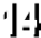
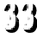
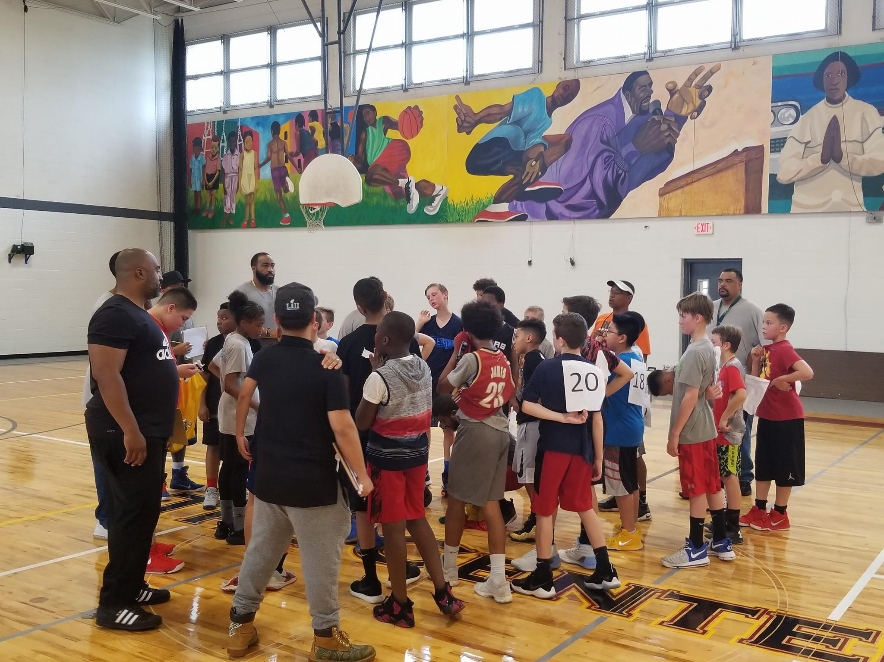
The Charles A. Melton Center Summer Basketball League Registration Form 2019

Coaches Meeting - April 1st @ 6pm In Auditorium

The Melton Center Basketball League is a co-ed league opened to all youth ages 7-16. All games take place at the Melton Center Outdoor Courts. The first games will be played on June 23. Subsequent games will be played on Sundays throughout July and August. Some games may be played on Wednesday evenings depending on the number of teams and if there are any rain dates.

 | Borough Residents | Non-Boro Residents
Registration Fee | $50* | 70*

Financial Aid Discounts are available on a sliding scale basis by contacting Ken Winston
Department office (610-692-9290)

$10 Late Fees will be added after May 9th
NO EXCEPTIONS
If you have any questions, please contact kennethwinston1@comcast.net
Assessments June 2nd June 9th

Draft June 16th

THE MELTON CENTER SUMMER BASKETBALL LEAGUE REGISTRATION
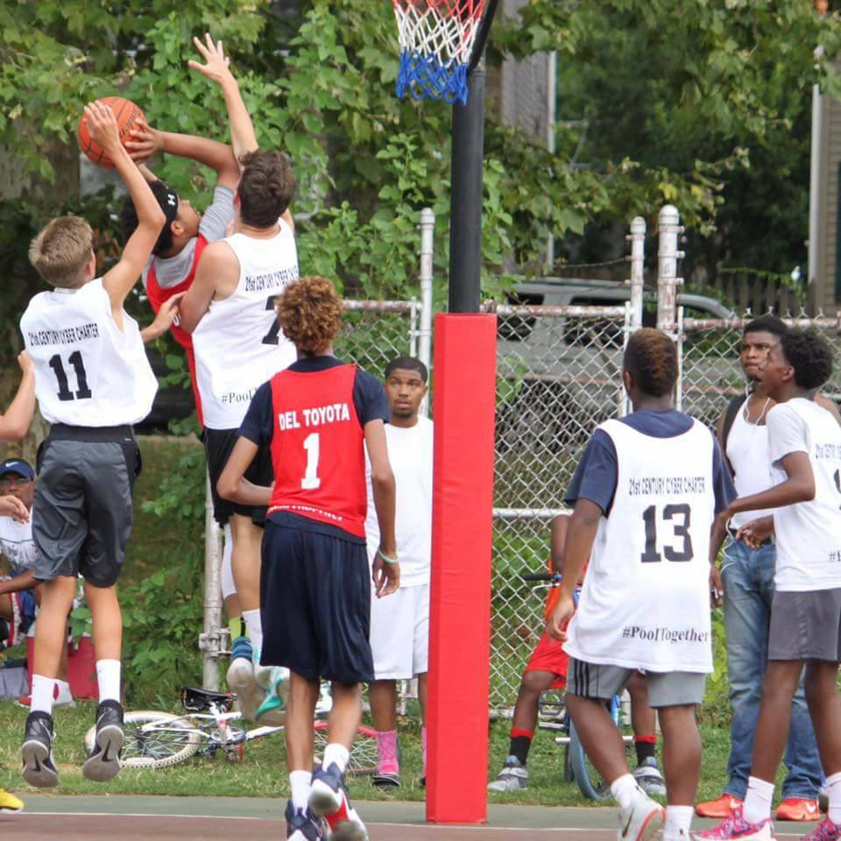
(ALL SECTIONS MUST BE COMPLETED)
Child’s Name: Medical Info. (Asthma etc.): Street Address: Height: Weight: City, State, Zip: Birth Date: Age: Home Phone: Gender: Parent Cell: Parent/Guardian name (print): Parent/Guardian signature:
Email:
**Please circle your preferred form of contact (contact information must be up to date), coaches will need to contact parents throughout the season**
First Game Sunday, June 23rd
Re-Scheduled Games Wednesday Evenings

Home Phone Cell Phone

Email

AGE GROUP please circle: 7-10-year-old 11-13-year-old 14-16-year-old

SHIRT SIZE please circle: CHILD SIZE: SMALL MEDIUM LARGE XL

SHIRTS DO RUN SMALL and are TRUE TO SIZE-no exchanges once t-shirts are ordered.

ADULT SIZE: SMALL MEDIUM LARGE XL XXL XXXL

RATE BASKETBALL ABILITY (1=Advanced, 2=Some Experience, 3=Little Experience or Beginner):

LIST BASKETBALL EXPERIENCE:

Please read the statements below and initial your acceptance:

I hereby consent to and authorize the use and reproduction, in print or electronic format Charles A. Melton Arts and Education Center (The Melton Center) or anyone authorized by (The Melton Center), of any and all photographs which are taken of my child(ren) during the program for any publicity purpose, without compensation. All images—electronic, negatives and positives, together with the prints, are owned by The Melton Center. By checking this box, I give me consent and acknowledge that I am the parent or legal guardian of the registered child.
I acknowledge that I have read and agree to abide by the Parent Code of Conduct

Parent & Player Codes of Conduct
The Melton Center Summer League Committee has implemented the following Player and Parent Code of Conduct. All Players and Parents (or legal guardians) must read, understand and sign this form prior to the player’s participation in our league.
By signing this form, the player and parent both provide their consent that a player who violates the Code of Conduct may be subject to disciplinary action by their team’s coach, in conjunction
with the Steering Committee. This disciplinary action may include a temporary suspension from the program or the forfeiture of the privilege to participate in the program for the season.

Parent’s Code of Conduct (or Legal Guardian):
- I (and my guests) will be a positive role model for my child and encourage sportsman- ship by showing respect and courtesy, and by demonstrating positive support for all players, coaches, officials and spectators at every game, practice or other sporting event.
- I (and my guests) will not engage in any kind of unsportsmanlike conduct with any official, coach, player or parent such as booing and taunting, refusing to shake hands, or using profane language or gestures.
- I will not encourage any behaviors or practices that would endanger the health and well-being of athletes.
- I will demand that my child treat other players, coaches, officials and spectators with respect at all times regardless of race, creed, color, sex or ability.
- I will never ridicule or yell at my child or other participants for making a mistake or losing a competition.
- I will respect the officials and coaches for their authority during games and practices;
I will never question, discuss, or confront coaches on the courts, but will take time to speak with coaches at an agreed-upon time and place.
- I will refrain from coaching my child or other players during games and practices, un- less I am one of the registered coaches for the team.

Parent’s Signature (or Legal Guardian):

I hereby authorize the Supervisors of the Melton Center Basketball League to act for me

according to their best judgment in any emergency requiring medical attention. (All efforts will be made to contact the parents first.) I hereby waive and release the Phoenixville Recreation Commission and Staff, The Melton Center staff and volunteers from all liability for any injuries that may occur during participation in the basketball program, or arising out of my child traveling to the pro- gram.
- Any canceled games due to weather will be played the following Wednesday
Please mail checks made payable to: The Melton Center or
registrations will be taken at The Melton Center form 10:00 am-4:00 pm Monday –Thursday ($10 late fee for all payment after May 9th)
501 E Miner Street
West Chester, PA 19382

Player’s Code of Conduct:
- I will show respect to all coaches, game officials, parents, teammates and opposing players at all times, and will never act in a manner that is disrespectful to them or my team.
- I will demonstrate good sportsmanship regardless of the score or situation by acting
in a positive manner towards coaches, officials and other players. I will help to clean the gymnasium/bench area at both home and away games.
- I will display good sportsmanship and a commitment to my team at all times.
- I will shake hands with the other team and officials after games.

Players’ Signature:

Player’s name printed:

