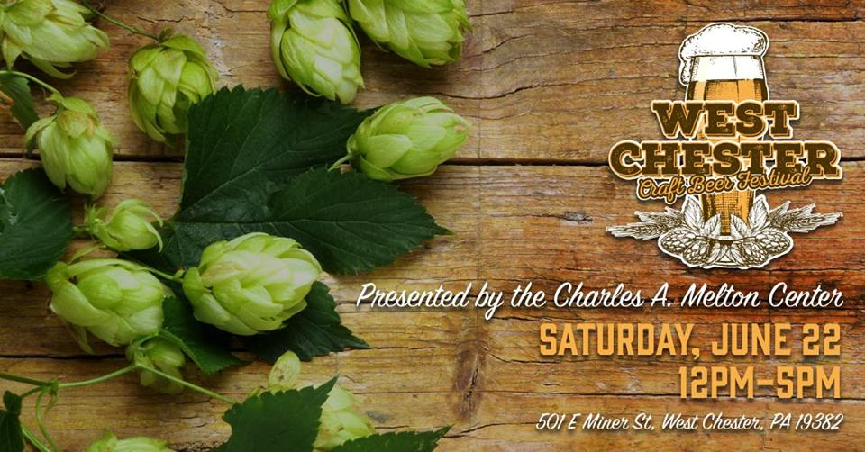

2019 SPONSORSHIP PACKAGE INFORMATION

 | PRESENTING | PREMIUM | GOLD | SILVER | BRONZE
PRICE | $5,000 | $2,500 | $1,000 | $500 | $250
TICKETS | 12 VIP Tickets  12 Meal Vouchers  ($10 each) | 8 VIP Tickets | 4 VIP Tickets | 2 tickets
PRESS RELEASE | Sponsor level and company name identified on all marketing for the event
COMPANY LOGO | -Logo displayed at event  -Full side table top tents with logo | -Logo displayed on event banner under appropriate sponsor  -Logo displayed on event emails & online events page  -Logo displayed on table top tents within sponsor category
DISPLAY PLACE | -Display table provided at premium location | -Logo displayed on event banner under appropriate sponsor  -Logo displayed on table top tents within sponsor category
ACKNOWLEDGEMENT | -Individually recognized  -Stage time | Company name recognized by sponsor level
PROMOTIONAL MATERIALS | Distribution of your company materials  to event attendees

EVENT SPECIALTY ITEM:
STAGE SPONSOR $1500

Your business name prominently displayed at/in front of or near the stage (depends on stage type used)

Please complete & submit attached form to confirm and secure sponsorship

Thank you!

WEST CHESTER  CRAFT BEER FESTIVAL  SPONSORSHIP FORM | Benefitting  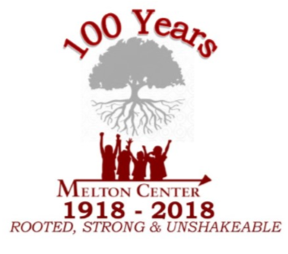

__ PRESENTING __ PREMIUM __ GOLD __SILVER __BRONZE
__ STAGE SPONSOR

COMPANY NAME:
CONTACT PERSON:
COMPANY ADDRESS:
PHONE#: EMAIL:

You will receive an invoice for the identified sponsorship level.
Please submit logo artwork to: kennethwinston1@comcast.net

Submit form to Kenneth Winston at:
kennethwinston1@comcast.net

Or mail form to:
The Charles A. Melton Arts and Education Center:
P.O. Box 834
West Chester, PA 19380-0834

Questions – please call: 610-692-9290

